|  |
| --- |
| Class-gameitem |
| GameItem();  b2Body *g_body;  繼承  QSizeF g_size;  QGraphicsPixmapItem g_pixmap;  ~*GameItem*();  static QSizeF g_worldsize, g_windowsize;  b2World *g_world; |
| static void setGlobalSize(QSizeF worldsize, QSizeF windowsize);  void paint(); |

|  |
| --- |
| Class-barrier |
| Barrier() |
|  |

|  |
| --- |
| Class-bird |
| Bird() |
| void setLinearVelocity(b2Vec2 velocity) |

繼承

繼承

|  |
| --- |
| Class-land |
| Land() |
|  |

執行

|  |
| --- |
| Class-pig |
| Pig() |
|  |

|  |
| --- |
| MainWindow |
| explicit MainWindow(QWidget *parent = 0);  ~*MainWindow*();  Bird *birdie1;  Bird *birdie2;  Bird *birdie3;  Bird *birdie4;  Bird *birdie5;  Bird *birdie6;  Bird *birdie7;  Barrier *bar1;  Barrier *bar2;  Barrier *bar3;  Barrier *bar4;  Barrier *bar5;  Barrier *bar6;  Barrier *bar7;  Barrier *bar8;  Pig *pig1;  Pig *pig2;  Pig *pig3;  Pig *pig4;  QPointF pt;  QSound *bgm  Ui::MainWindow *ui;  QGraphicsScene *scene;  b2World *world;  QList<int> rand_list;  QList<GameItem *> itemList;  QList<Bird *>birdlist;  QTimer timer;  int repeat;  static QSizeF g_worldsize, g_windowsize;  int b; |
| void *showEvent*(QShowEvent *);  bool *eventFilter*(QObject *,QEvent *event);  void *closeEvent*(QCloseEvent *);  void *keyPressEvent*(QKeyEvent *keye);  void *mousePressEvent*(QGraphicsSceneMouseEvent *mouse);  void quitGame()  void tick();  void QUITSLOT(); |

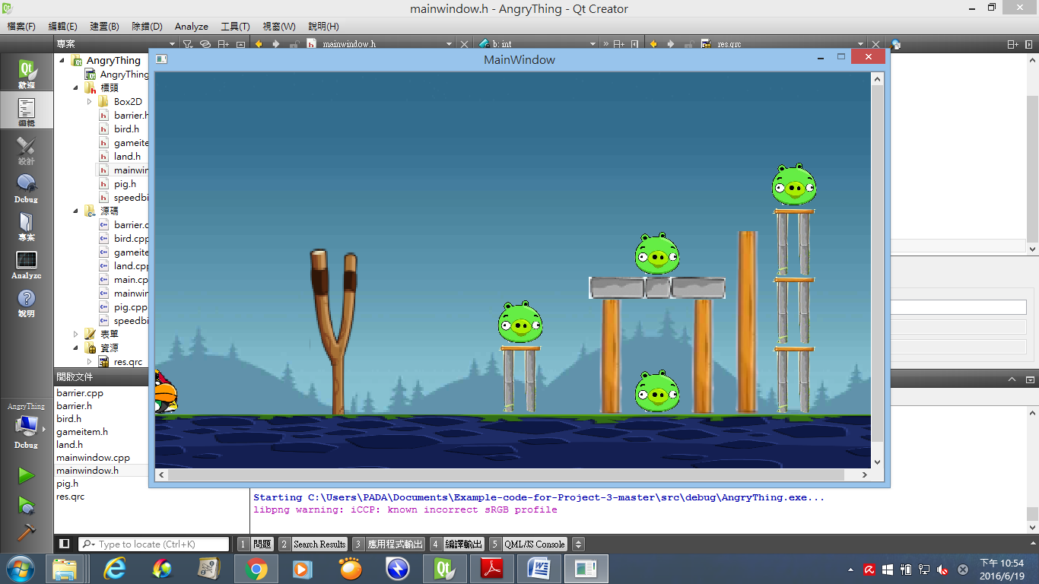

由此往任意方向拉(不超過彈弓)，鳥就會往外射

產生的鳥

產生的豬及障礙物

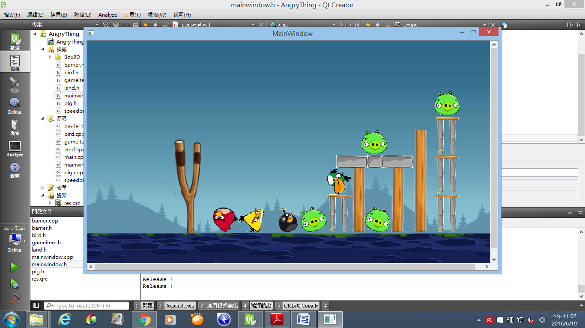

分身+變大 (4),(5),(R)

噴火(3),(E)

加速

(2),(W)

普通的鳥(Q)